TASK 4 : IMAGE-TO-IMAGE TRANSLATION WITH cGAN
Description : Implement an image-to-image translation model using a conditional generative adversarial network (cGAN) called pix2pix.
CODING:
import torch
import torch.nn as nn
import torch.optim as optim
from torch.utils.data import DataLoader, Dataset
import torchvision.transforms as transforms
from torchvision.utils import save_image
from PIL import Image
import os

# Generator (U-Net)
class UNetGenerator(nn.Module):
def __init__(self, in_channels=3, out_channels=3):
super(UNetGenerator, self).__init__()

def down_block(in_feat, out_feat, normalize=True):
layers = [nn.Conv2d(in_feat, out_feat, 4, stride=2, padding=1)]
if normalize:
layers.append(nn.BatchNorm2d(out_feat))
layers.append(nn.LeakyReLU(0.2, inplace=True))
return nn.Sequential(*layers)

def up_block(in_feat, out_feat, dropout=0.0):
layers = [
nn.ConvTranspose2d(in_feat, out_feat, 4, stride=2, padding=1),
nn.BatchNorm2d(out_feat),
nn.ReLU(inplace=True)
]
if dropout:
layers.append(nn.Dropout(dropout))
return nn.Sequential(*layers)

self.down1 = down_block(in_channels, 64, normalize=False)
self.down2 = down_block(64, 128)
self.down3 = down_block(128, 256)
self.down4 = down_block(256, 512)

self.up1 = up_block(512, 256)
self.up2 = up_block(512, 128)
self.up3 = up_block(256, 64)
self.final = nn.Sequential(
nn.ConvTranspose2d(128, out_channels, 4, stride=2, padding=1),
nn.Tanh()
)

def forward(self, x):
d1 = self.down1(x)
d2 = self.down2(d1)
d3 = self.down3(d2)
d4 = self.down4(d3)

u1 = self.up1(d4)
u2 = self.up2(torch.cat([u1, d3], 1))
u3 = self.up3(torch.cat([u2, d2], 1))
return self.final(torch.cat([u3, d1], 1))

# Discriminator (PatchGAN)
class PatchDiscriminator(nn.Module):
def __init__(self, in_channels=6):
super(PatchDiscriminator, self).__init__()
def block(in_feat, out_feat, normalize=True):
layers = [nn.Conv2d(in_feat, out_feat, 4, stride=2, padding=1)]
if normalize:
layers.append(nn.BatchNorm2d(out_feat))
layers.append(nn.LeakyReLU(0.2, inplace=True))
return layers

self.model = nn.Sequential(
*block(in_channels, 64, normalize=False),
*block(64, 128),
*block(128, 256),
nn.Conv2d(256, 1, 4, padding=1)
)

def forward(self, img_A, img_B):
# Concatenate input and target images
img_input = torch.cat((img_A, img_B), 1)
return self.model(img_input)

# Simple Custom Dataset
class ImagePairDataset(Dataset):
def __init__(self, root_dir, transform=None):
super(ImagePairDataset, self).__init__()
self.files = os.listdir(root_dir)
self.root_dir = root_dir
self.transform = transform

def __len__(self):
return len(self.files)

def __getitem__(self, idx):
img_path = os.path.join(self.root_dir, self.files[idx])
img = Image.open(img_path).convert('RGB')
w, h = img.size
img_A = img.crop((0, 0, w//2, h)) # Left side
img_B = img.crop((w//2, 0, w, h)) # Right side

if self.transform:
img_A = self.transform(img_A)
img_B = self.transform(img_B)
return img_A, img_B

# Training Parameters
device = torch.device('cuda' if torch.cuda.is_available() else 'cpu')
epochs = 200
batch_size = 1
learning_rate = 2e-4
lambda_L1 = 100

# Transformations
transform = transforms.Compose([
transforms.Resize((256, 256)),
transforms.ToTensor(),
transforms.Normalize((0.5,), (0.5,))
])

# Load Dataset
dataset = ImagePairDataset(root_dir="data/", transform=transform)
dataloader = DataLoader(dataset, batch_size=batch_size, shuffle=True)

# Initialize models
generator = UNetGenerator().to(device)
discriminator = PatchDiscriminator().to(device)

# Loss functions
criterion_GAN = nn.MSELoss()
criterion_L1 = nn.L1Loss()

# Optimizers
optimizer_G = optim.Adam(generator.parameters(), lr=learning_rate, betas=(0.5, 0.999))
optimizer_D = optim.Adam(discriminator.parameters(), lr=learning_rate, betas=(0.5, 0.999))

# Training Loop
for epoch in range(epochs):
for i, (real_A, real_B) in enumerate(dataloader):
real_A, real_B = real_A.to(device), real_B.to(device)

# Train Generator
optimizer_G.zero_grad()

fake_B = generator(real_A)
pred_fake = discriminator(real_A, fake_B)
valid = torch.ones_like(pred_fake).to(device)

loss_GAN = criterion_GAN(pred_fake, valid)
loss_L1 = criterion_L1(fake_B, real_B) * lambda_L1
loss_G = loss_GAN + loss_L1

loss_G.backward()
optimizer_G.step()

# Train Discriminator
optimizer_D.zero_grad()

pred_real = discriminator(real_A, real_B)
loss_real = criterion_GAN(pred_real, valid)

pred_fake = discriminator(real_A, fake_B.detach())
fake = torch.zeros_like(pred_fake).to(device)
loss_fake = criterion_GAN(pred_fake, fake)

loss_D = (loss_real + loss_fake) * 0.5

loss_D.backward()
optimizer_D.step()

if i % 50 == 0:
print(f"Epoch [{epoch}/{epochs}] Batch [{i}/{len(dataloader)}] \
Loss D: {loss_D.item():.4f}, Loss G: {loss_G.item():.4f}")

# Save output samples every epoch
save_image(fake_B, f"outputs/{epoch}_fake.png", normalize=True)
save_image(real_B, f"outputs/{epoch}_real.png", normalize=True)

INPUT:
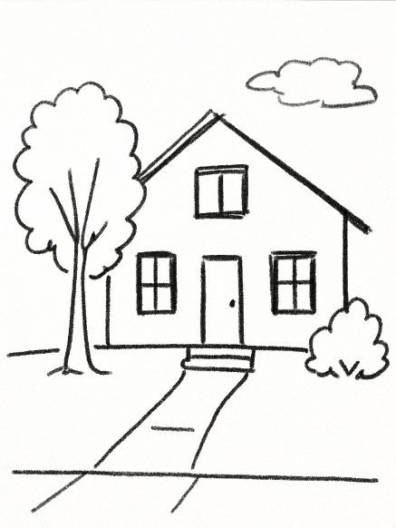

OUTPUT:

